**IOS Automation Installtion Process and Run First script**

**1) Install Xcode**

Launch the Mac AppStore and download/install Xcode for Simulators.

sudo xcode-select --switch /Applications/Xcode.app

**2) Install Node & NPM**

Appium is a server, written using node. js and to run Appium server we are using npm Command is brew install node

**3) Install Appium Desktop**

Appim server communicate between Eclips Tool and the Simulator using the WebDriver protocol.

**4) Install Carthage by terminal**

Carthage is a dependency manager for WebDriverAgent.

sudo chown -R $(whoami) $(brew --prefix)/*

brew install carthage

**5)** **Install Eclipse**

Eclipse is the Integrated Development Environment (IDE) that we are going to use to write, compile and run our test scripts.

**6) Install Python 3.8**

To run robot framework and python 3.8 supports more feature then previous one for robot framework

**7) Install Robot framework Library in python 3.8 by terminal**

Pip3 install robotframework-appiumlibrary

Pip3 install pypyodbc

Note:- You can add more as per requirement, these are mandatory for IOS

**8) IOS build file, extension as .app file given by developer**

For Example :- MSP.app file to run in Simulator

1. Open terminal

B. Enter command “open –a simulator”

C. Drag Drop .app file

D. Check by opning app is working Properly or not

**9) Opening of the .app file in simulator without any permisson isuue**

A.Open Terminal

Enter commnad “sudo spctl --master-disable”

B.Check status

Enter Command Spctl –status and status should be “assessments disabled”

C. Go to the Security and Privacy and select Anywhere

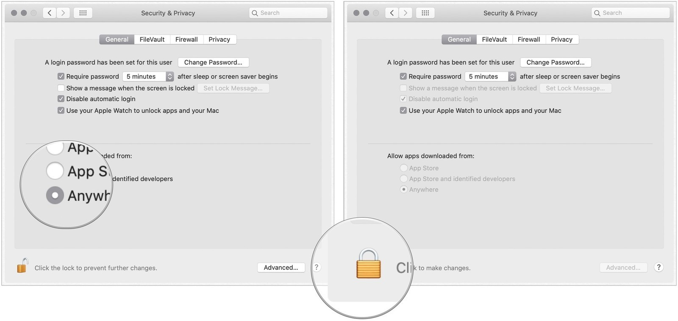

**10) Use of Appium Inspector to find Locators.**

A. Open Appium and follow below steps

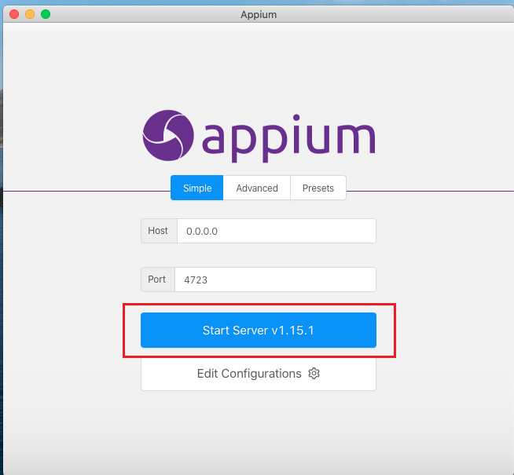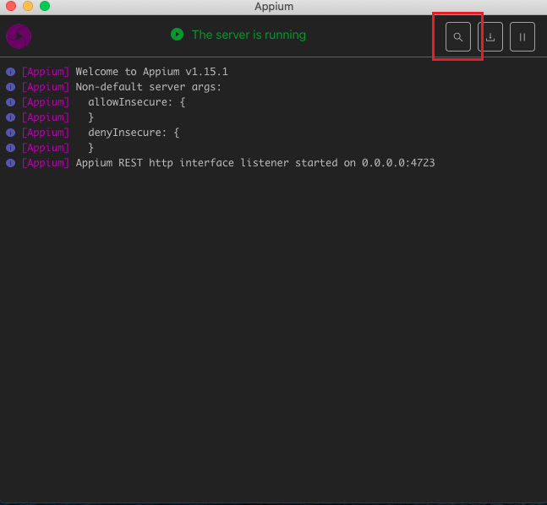

B. Enter Desired capabilities according to platform and device

{

"platformName": "IOS",

"platformVersion": "13.3",

"deviceName": "iPhone 8",

"automationName": "XCUITest",

"app": "/Users/pere-dev/Desktop/UICatalog.app"

}

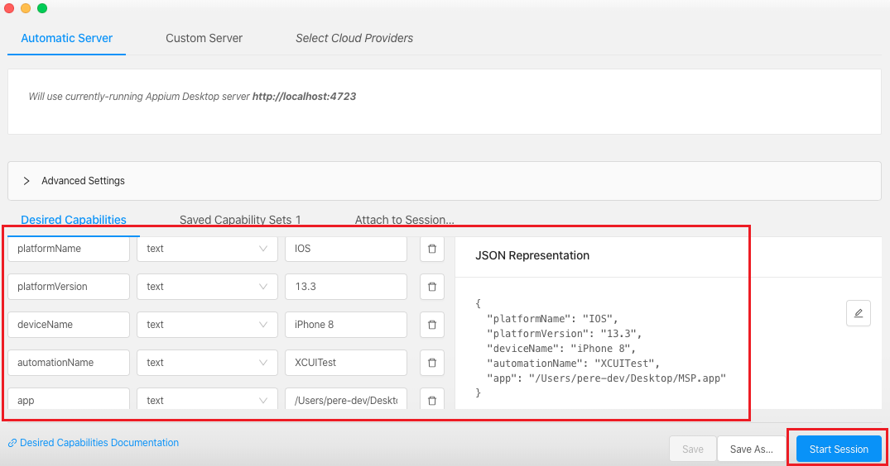

C. After Start session it takes few seconds to open the below screen and opensimulator, you can use that screen for finding locator and Xpath

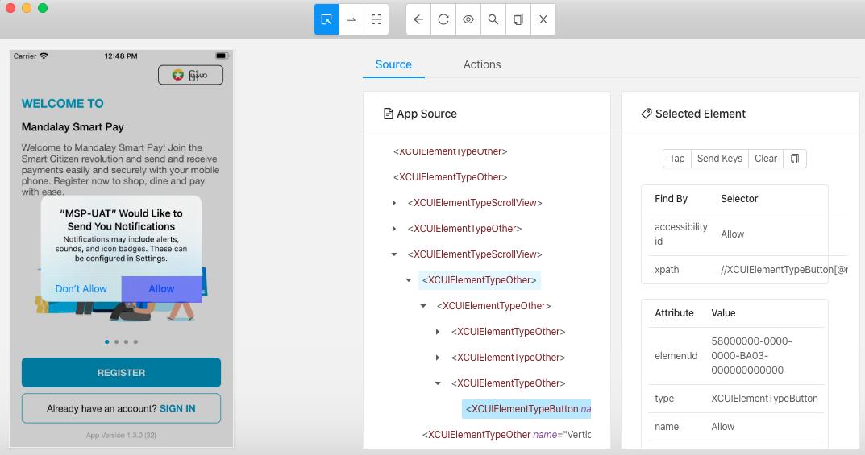

**11) Add Robot Library in eclips and Run First code in MAC**

After create robot file need to add library in that for that follow below steps

1. Right Click on Robot File
2. Select option “Robot Framework”
3. Select option “Automatically discover and libraries to red.xml
4. All libraries related to the script are fetched for use

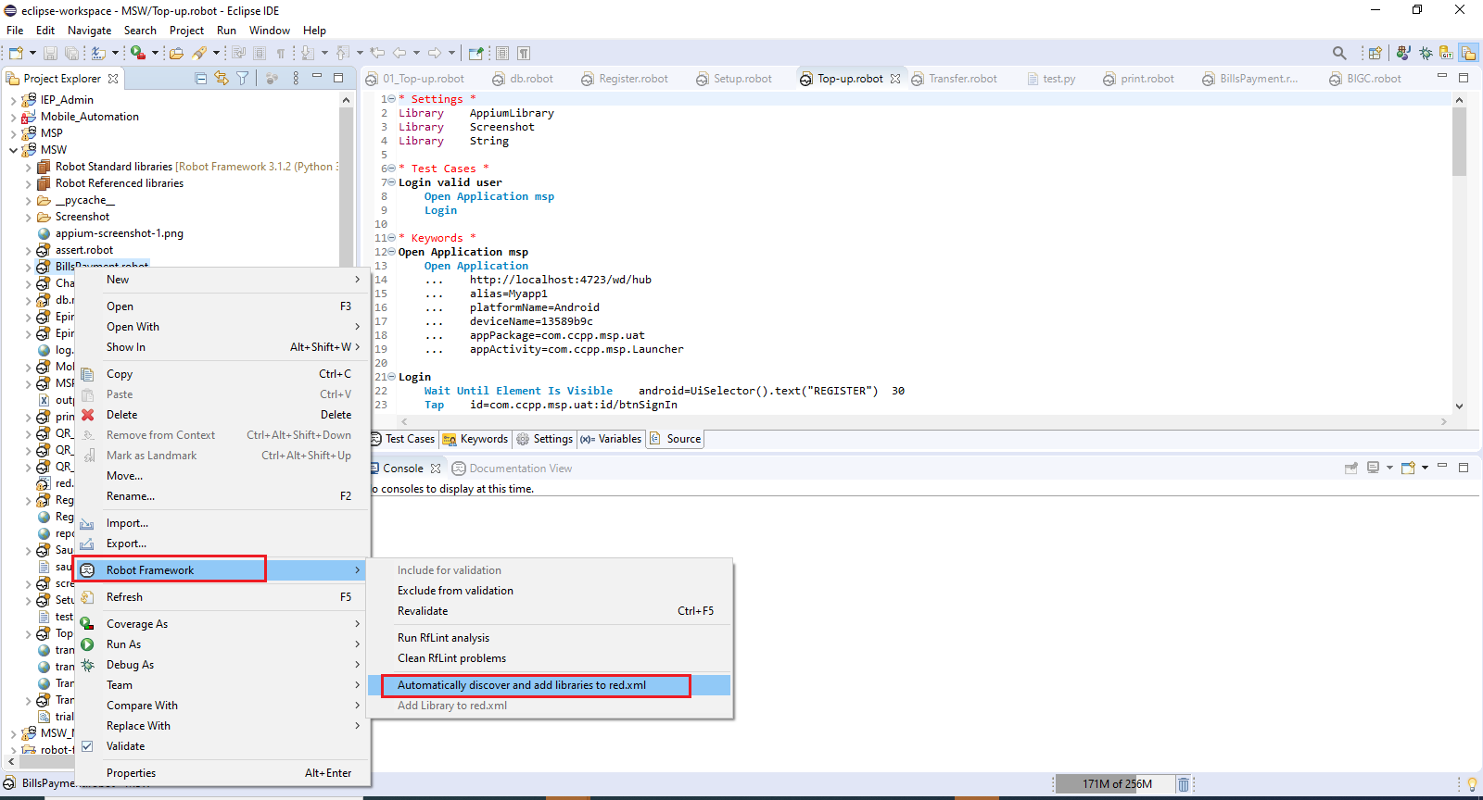

**12) Sample code for IOS app open**

*** Settings ***

Library AppiumLibrary

*** Variables ***

${REMOTE_URL} http://127.0.0.1:4723/wd/hub

${PLATFORM_NAME} iOS

${PLATFORM_VERSION} 13.3

${DEVICE_NAME} iPhone 8

${APP_LOCATION} /Users/pere-dev/Desktop/MSP.app

${BUNDLE_ID} com.ccpp.msp

${AppActivity} com.ccpp.msp.Launcher

*** Test Cases ***

Invoke IOS App

Open MSP APP

*** Keywords ***

Open MSP APP

Open Application ${REMOTE_URL}

... platformName=${PLATFORM_NAME}

... platformVersion=${PLATFORM_VERSION}

... deviceName=${DEVICE_NAME}

... automationName=appium

... bundleId=${BUNDLE_ID}

... appActivity=${AppActivity}

Wait until element is visible //XCUIElementTypeStaticText[@name="Already have an account? SIGN IN"] 10s

Tap //XCUIElementTypeStaticText[@name="Already have an account? SIGN IN"]